Effects of changing different parameters on fit to early life low oxygen data

What time to hatch and change in length would this fit predict for conditions of experiment. Not fitting but simulating.

1. List parameters that give best fit to early life control data
   1. Edited calc_and_plot.m code to add an option to manually set axis limits.
   2. Enter in all data for 4 oxygen levels so it can be plotted.
      1. May also want a version with just two oxygen levels to make it easier to see.
2. For one parameter at a time, change it to get it closer to the low oxygen data and record what the different values do for each data type.
   1. How big of a change in value does it take to get close to the hypoxia data?
   2. Does it affect all of the data types or just some?

Best fit to control data for early life only (up to 110 days post fertilization)

Based on data, manual fitting, and model fitting

|  |  |  |  |
| --- | --- | --- | --- |
| Parameter | Name | Value | Fixed/Estimated |
| delM | Shape corrector | 0.1066 | Fixed (data) |
| dV | Dry weight density | 0.288 | Fixed (data) |
| sJAm | Area-specific assimilation rate | 0.302 (AIC=104.33) | Estimated |
| sJM | Mass-specific maintenance costs | 0.02143 (AIC=101.03) | Both |
| WB0 | Initial egg weight | 0.15 | Fixed (data) |
| Lwp | Length at puberty | 115 | Fixed (data) |
| yAV | Yield of assimilates on vol (starv) | 0.8 | Fixed (default) |
| yBA | Yield of egg buffer on assimilates | 0.95 | Fixed (default) |
| yVA | Yield of structure on assimilates | 0.35 (AIC=100.85) | Estimated |
| kap | Kappa fraction to soma | 0.7 (AIC=106.33) | Estimated |
| f | Scaled food level | 1 | Fixed (data) |
| fB | Scaled food level, embryo | 1 | Fixed |
| Lwf | Half-saturation length | 0 | Fixed |
| mu_emb | Mortality rate, embryo | 0.06624 (AIC=224.2) | Estimated |
| mu_lar | Mortality rate, larvae | 0.02809 (AIC=223.39) | Estimated |

Minus log likelihood = 110.445 when run simulation with fitting turned off using the individually estimated parameters.

Effect of reducing sJAm (area-specific assimilation rate)

|  |  |
| --- | --- |
|  | Best fitting parameter value |
| 7.7 mg/L | 0.302 |
| 4 mg/L | 0.25 |
| 3 mg/L | 0.20 |
| 2.5 mg/L | 0.25* |

*No later larval length for 2.5 mg/L oxygen level, so the best fit is based on only hatch length.

* This shifts the growth line down, but the early-life data points are closer together so as you get closer to the later larval lengths for hypoxia, the fit to the hatch lengths gets worse.
* Ideally would find a parameter that affects later larval length more than hatch length.
* This accounts well for the change in hatch timing. Decreasing sJAm by 0.05 delays hatching by about 1 day.
* It doesn’t get survival as low as it should be for 2.5 mg/L.
* Easy to justify because previous

Effect of increasing sJM (maintenance)

|  |  |
| --- | --- |
|  | Best fitting parameter value |
| 7.7 mg/L | 0.02143 |
| 4 mg/L | 0.07 |
| 3 mg/L | 0.16 |
| 2.5 mg/L | 0.19* |

* Increasing sJM increases the curvature of the predicted growth curve.
  + Intake is proportional to area and maintenance is proportional to volume
  + This is why curvature is dependent on maintenance.
  + For early life some people use everything is proportional to length cubed. This gives exponential growth.
  + Write that this is completely expectd because of the form of the model.
* It needs to be more than tripled to get close to the low oxygen treatments.
* Even at the increases required to reduce larval length, hatch timing is only slightly delayed (less than a day). As a result, survival is also unaffected.

Effect of reducing yVA

|  |  |
| --- | --- |
|  | Best fitting parameter value |
| 7.7 mg/L | 0.35 |
| 4 mg/L | 0.3 |
| 3 mg/L | 0.23 |
| 2.5 mg/L | 0.19* |

* Similar to sJAm, this changes the slope of the line but not the curvature.
* Reducing yVA delays hatching.
* The effects on survival are still small.

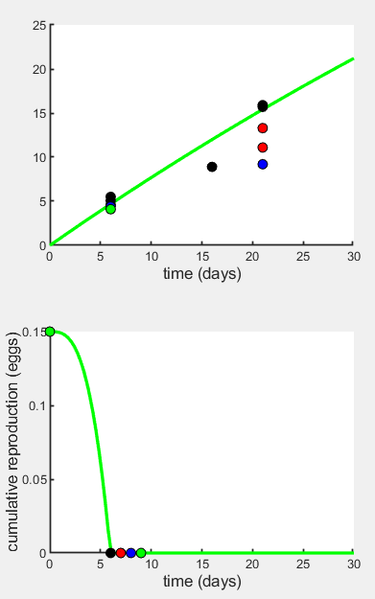 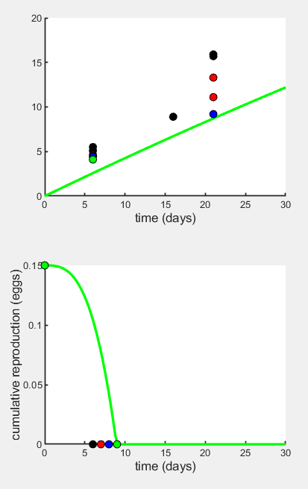

yVA = 0.35 yVA = 0.19

Effect of increasing mu_emb

|  |  |
| --- | --- |
|  | Best fitting parameter value |
| 7.7 mg/L | 0.06624 |
| 4 mg/L | 0.07 |
| 3 mg/L | 0.025 |
| 2.5 mg/L | 0.2 |

* The survival rate for 3 mg/L was close to the greater of the two data points for 4 mg/L and there was only one experiment for 3 mg/L, so a lower mu_emb actually fits better.
  + These are means across 5 replicate tanks in each experiment – should I use the raw numbers instead of means?
* Survival effects were worst at 2.5 mg/L so a non-linear effect on survival may be necessary, and altering larval survival would also be necessary to fit both data points for 2.5 mg/L.

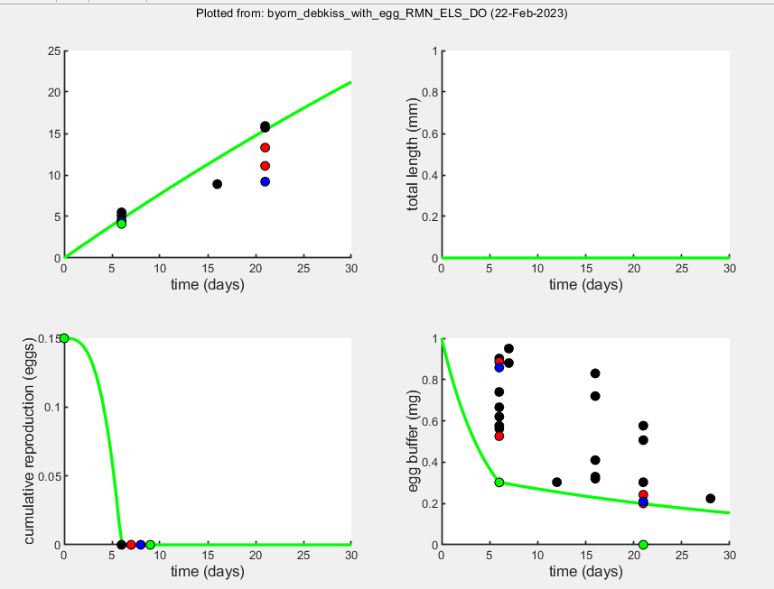

Notes on adding oxygen treatments to DEBkiss code

Resource: <https://www.debtox.info/downloads/byom/html_byom/byom_bioconc_start.html>

1. Added data from four treatments (or ‘scenarios’ as Jager refers to them) to the byom_debkiss_with_egg code.
   1. Used NaN when a control (7.7 mg/L) data point did not have a corresponding low oxygen data point.
   2. Weight factors are number of replicates (when available).
   3. Also added a column to X0mat for each scenario.
   4. Set glo.locL = 2 and glo.locR = 3, to tell it that body size and reproduction are 2nd and 3rd in the state variable list, respectively.
2. Adding oxygen data so that it can be a state variable that controls how parameters are affected (or not) by a stress function.
   1. ~~This was based on a BYOM walkthrough by Tjalling Jager where he had external concentration of a toxicant as one state variable and internal concentration as another state variable.~~
   2. ~~The predicted external concentration is controlled by the animal’s uptake rate, and the predicted internal concentration is in part controlled by the external concentration at each scenario via the parameters.~~
   3. ~~Similar to internal concentration, I want the predicted values of the other state variables to be influenced by oxygen via parameter(s), and I want the influence to be different for different scenarios (hypoxia levels). So it seemed like one way to do this is add oxygen as a state variable (similar to external concentration).~~
   4. ~~None of the parameters~~ *~~affect~~* ~~oxygen and I set the derivative equal to zero so it stays constant, but this way as the predicted values of data are calculated for each point in time during parameter estimation it can use the oxygen to do so.~~
   5. ~~Problem: The AIC/NLL calculation may be using the oxygen state variable as a source of variance so I may need to figure out how to exclude it from that.~~
   6. UPDATE: Now adding oxygen (DO) as zero-variate data.
3. Adding a stress function to the derivatives.m code with if/else functions to alter a parameter within the relevant DEBkiss equations based on being above or below an oxygen threshold.
   1. Still working on this, but I used the stress functions from Jager (2018) table 5.2, and drafted a few lines to add to the equations for the parameter of interest, using yVA and the equation for growth as an example below.
   2. Original: JV = yVA * (kap * JA – JM)
   3. With stress function:

if DO > 6

JV = yVA * (kap * JA – JM)

else

JV = yVA*(1-s) * (kap * JA – JM)

* 1. Still need to add code to define s (stress level, a number from 0-1 inversely related to oxygen).

Put this in, use all data, for some definition of s – estimate s that would fit all of the data

Then could look at effects of two parameters but hypothesize that they are affected the same way by stress

Once oxygen is specified there would be a formula relating stress to oxygen which would have a parameter

S is the y in y=mx+b, I want to find m (or different parameter if not linear) – can estimate with different scenarios

S=1 if DO < A

S=0 if DO > B

S=1/(B-A) if A<DO<B

S=1-(DO-A)/B-A) if A<DO<B

Estimate s for each level using this formula and see how close to data I get

New steps for adding oxygen effects to DEBkiss model

February 22, 2023

Resources: DEBkiss book Ch. 5 (Jager, 2018), BYOM manual Ch. 2 (Jager, 2015), and BYOM walkthrough <https://www.debtox.info/downloads/byom/html_byom/byom_bioconc_extra.html>

1. Add oxygen as forcing variable. The way to do this is explained in the online BYOM manual (the code for this in the PDF of the manual is outdated).
   1. In byom_debkiss_with_egg_RMN_ELS_DO.m I added the oxygen levels for each scenario and time point from the state variable data.
   2. Below that, a function is used to make a linear interpolation so that DO can be sampled from any time, not just the ones input, when calculating the model predictions. This is written as: make_scen(4,DO), and the first argument tells it which type of interpolation to use (4=linear).
   3. In the derivatives.m code give it the DO with interpolation using: DO = read_scen(-1,c,t,glo), where the first argument tells it which function (-1 = derivatives, return one concentration) it is being called from.
2. Separately, in the base model estimate the parameters with all of the data and see how well it fits just the early life data.
   1. **Should I do the hypoxia model with just the early life data and use the parameters from the full life base model, or leave the full life data in for hypoxia stuff? This seems important. Would have to justify leaving out the later life data I think.**
   2. Also changed Lwp to 110 because I realized 115 didn’t make sense with the length data point (323,111.4) and reproduction data starting before 323 days (and both are from the same paper). Fish base says max length is 150 but common length is 115 mm.
3. Replace the means with individual data points for each tank, and possibly combine the 3 and 2.5 mg/L treatments.
   1. For the long term survival experiment the raw data (by tank) are not available so I will weight them by the number of tank replicates. But may be able to get individual tank data eventually.
   2. Question: this makes the data have a very wide spread. Is it better to just use the data from the hypoxia experiment and the long term experiment (base model), and leave out the extra early life survival data from other experiments?
   3. **Should I do this for length too? Separate out the replicate tanks (not individual fish that is way too many).**
4. Determine the upper and lower oxygen thresholds.
   1. Lower could be Pcrit?
   2. Upper could be ~4 since that is the level we know effects start happening. Or 4.6, since the mean±SD was 4.2±0.35 mg/L.
5. Add code to derivatives.m that tells it the stress function and how to apply it to parameters.
   1. Use two thresholds, A is lower threshold at which stress = 1 and B is the upper threshold at which stress = 0, and a linear stress function between them. The function calculates the y-value (stress) for any x-value (oxygen) between these two thresholds.
   2. Function: s = 1 – (DO – A) / (B – A)
6. Estimate parameters to best fit each dataset when stress function is applied, and determine which parameter and stress combo best fits the hypoxia data. .

Parameters for best fit to full life dataset

par.sJAm = [0.3270 0 0 1e6]; % specific assimilation rate

par.sJM = [0.0214 0 0 1e6]; % specific maintenance costs - fix

par.WB0 = [0.15 0 0 1e6]; % initial weight of egg - fix, based on data

par.Lwp = [100 0 0 1e6]; % total length at puberty - fix, egg production starts

par.yAV = [0.8 0 0 1]; % yield of assimilates on volume (starvation)

par.yBA = [0.95 0 0 1]; % yield of egg buffer on assimilates (repro)

par.yVA = [0.3646 0 0 1]; % yield of structure on assimilates (growth)

par.kap = [0.8 0 0 1]; % allocation fraction to soma - fix

par.f = [1 0 0 2]; % scaled food level - fix

par.fB = [1 0 0 2]; % scaled food level, embryo - fix

par.Lwf = [0 0 0 1e6]; % half-saturation total length - fix

par.mu_emb = [0.06393 0 0 1e6]; % mortality rate for embryos

par.mu_lar = [0.02940 0 0 1E6]; % mortality rate for larvae

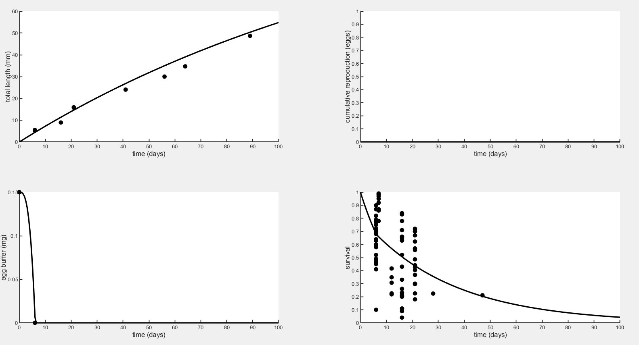

If I turn off the oxygen forcing variable and run with fitting turned off for the early life DO data using the parameters I had been using, Minus log-likelihood is 277.122. These are the parameters:

par.sJAm = [0.30 0 0 1e6]; % specific assimilation rate

par.sJM = [0.02143 0 0 1e6]; % specific maintenance costs - fix

par.WB0 = [0.15 0 0 1e6]; % initial weight of egg - fix, based on data

par.Lwp = [110 0 0 1e6]; % total length at puberty - fix, based on data

par.yAV = [0.8 0 0 1]; % yield of assimilates on volume (starvation)

par.yBA = [0.95 0 0 1]; % yield of egg buffer on assimilates (repro)

par.yVA = [0.35 0 0 1]; % yield of structure on assimilates (growth)

par.kap = [0.7 0 0 1]; % allocation fraction to soma - fix

par.f = [1 0 0 2]; % scaled food level - fix

par.fB = [1 0 0 2]; % scaled food level, embryo - fix

par.Lwf = [0 0 0 1e6]; % half-saturation total length - fix

par.mu_emb = [0.06624 0 0 1e6]; % mortality rate for embryos

par.mu_lar = [0.02809 0 0 1E6]; % mortality rate for larvae

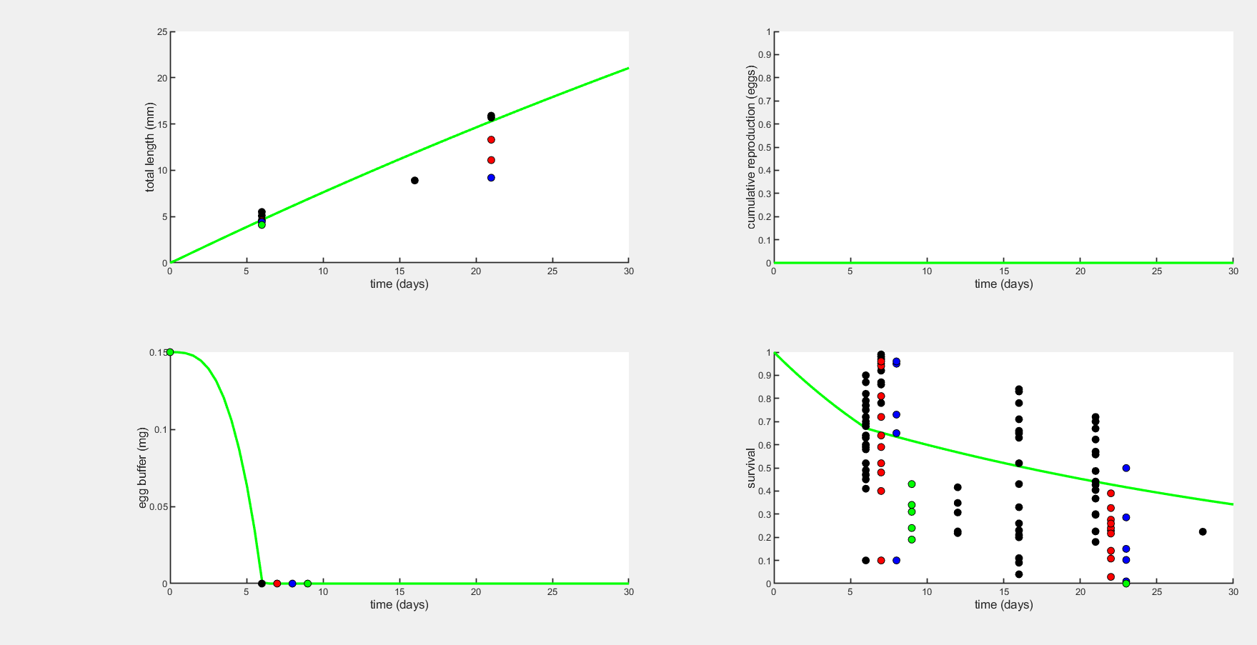

If I put in the new parameters based on fitting to full life this is what I get:

Minus log-likelihood = 287.852. It’s not that far off, but then again it should be lower with less data.

If fit for sJAm I get 0.3337 and Minus LogLik = 43.46

If fit for yVA (without changing sJAm to the new value) I get 0.3760 and Minus LogLik = 53.12

Because sJAm reduced it more, set sJAm = 0.3337 and then fit for yVA.

I get yVA = 0.3646 same as starting value, and Minus LogLik = 50.49.

But when I run with fitting turned off I get Inf… Maybe just use the initial parameters from the full life base model. The Minus LogLik = 287.852. I don’t understand why it gets so low when I try to fit the sJAm or yVA to get hatching closer to accurate.

If I use sJAm = 0.333 that works and reduces Minus LogLik to 273.56.

glo.delM = 0.1066; % shape corrector (used in call_deri.m)

glo.dV = 0.4; % dry weight density (used in call_deri.m)

glo.len = 2; % switch to fit physical length

glo.mat = 1; % include maturity maint. (0=off, 1=include)

% Note: if glo.len > 0 than the initial state for size in X0mat is length too!

% syntax: par.name = [startvalue fit(0/1) minval maxval optional:log/normal scale (0/1)];

par.sJAm = [0.333 0 0 1e6]; % specific assimilation rate

par.sJM = [0.0214 0 0 1e6]; % specific maintenance costs - fix

par.WB0 = [0.15 0 0 1e6]; % initial weight of egg - fix, based on data

par.Lwp = [100 0 0 1e6]; % total length at puberty - fix

par.yAV = [0.8 0 0 1]; % yield of assimilates on volume (starvation)

par.yBA = [0.95 0 0 1]; % yield of egg buffer on assimilates (repro)

par.yVA = [0.3646 0 0 1]; % yield of structure on assimilates (growth)

par.kap = [0.8 0 0 1]; % allocation fraction to soma - fix

par.f = [1 0 0 2]; % scaled food level - fix

par.fB = [1 0 0 2]; % scaled food level, embryo - fix

par.Lwf = [0 0 0 1e6]; % half-saturation total length - fix

par.mu_emb = [0.06393 0 0 1e6]; % mortality rate for embryos

par.mu_lar = [0.02940 0 0 1E6]; % mortality rate for larvae